**Dominic Townsend’s Programming Tutorials**

**Main Menu**

1. Create three scenes: a main menu, and options menu and a first level (or whatever the “Play” button will link to).

2. In the Main Menu scene, create three buttons and label them accordingly in the hierarchy.

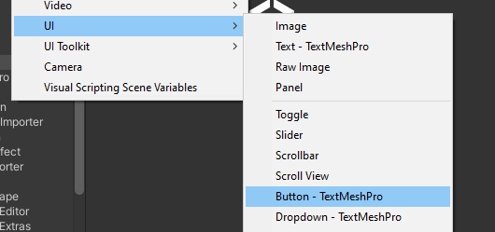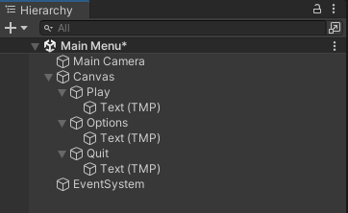

3. In the Canvas settings, set the UI Scale Mode to “Scale With Screen Size”, the Reference Resolution to 1080p and the Match value to 0.5.

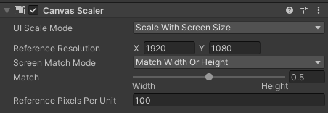

4. Create an empty GameObject called “MainMenu”, and add the three buttons to it as children.

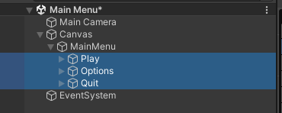

5. Adjust the position and size of each button using Pos X/Y, Width and Height.

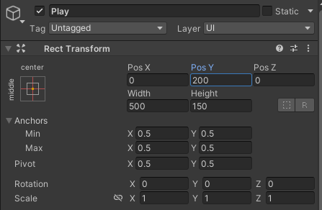

6. Edit the text attributes of each button in the TextMeshPro – Text settings.

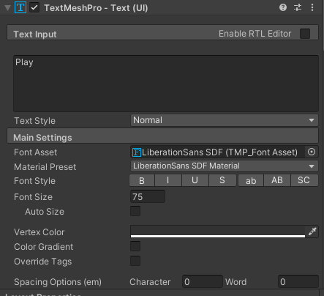

7. If done correctly, the buttons should look like this:

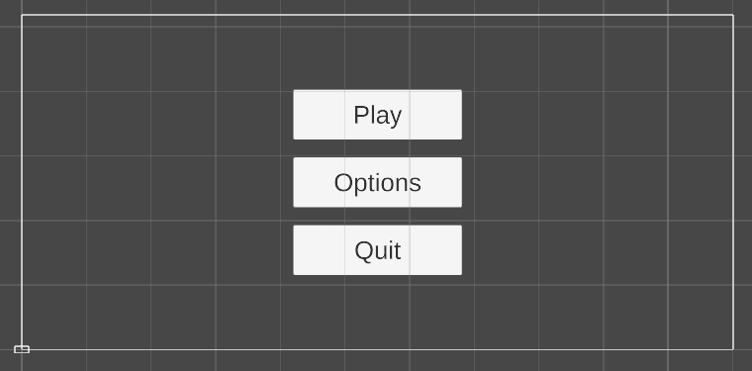

8. Create a C# script and name it “MainMenu.cs”.

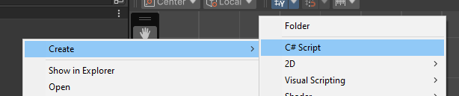

9. Write the following code. Make sure to add “using UnityEngine.SceneManagement”, as this isn’t present by default.

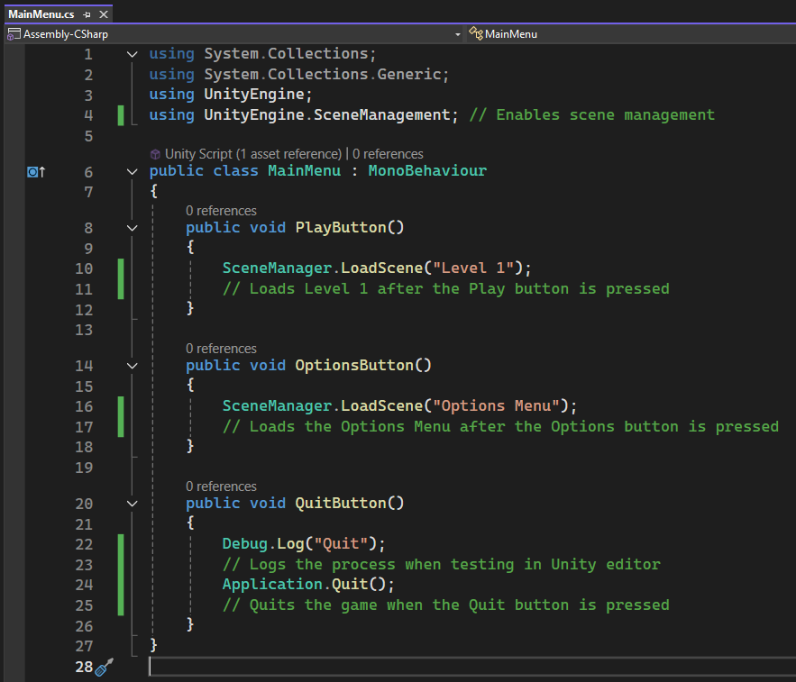

10. Add the script to the MainMenu GameObject.

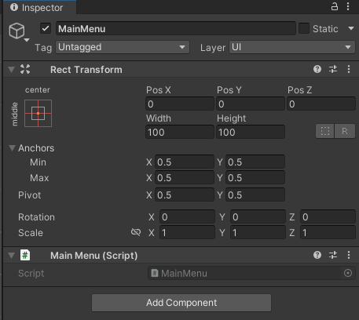

11. In each button’s settings, add the MainMenu GameObject in the “On Click ()” tab, and select the respective button in the dropdown menu on the right.

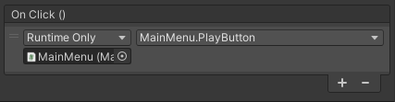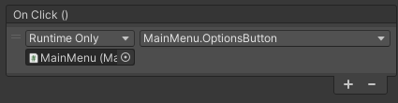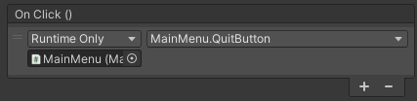

12. Open the project’s Build Settings (File > Build Settings), drag the scenes from the assets folder to the “Scenes In Build” tab and close the window.

13. Optionally, a custom image can be applied to each button by adding it to the Source Image setting.

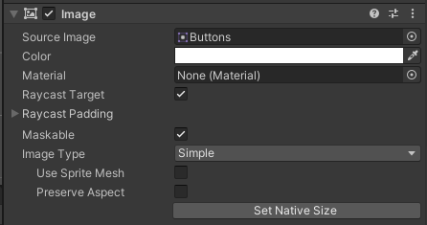

14. The buttons should now direct you to their respective menus. If a source image is present, they should also be displaying it.

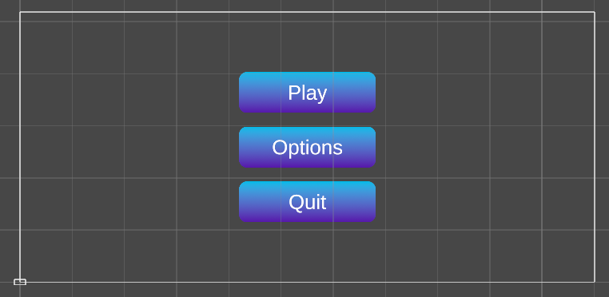

15. In the Options Menu scene, go through the same initial steps to make buttons, but only make one called “Return” (used to return to the main menu). An empty GameObject like MainMenu isn’t needed for a singular button.

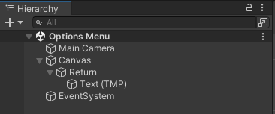

16. Create a C# script called “OptionsMenu.cs” and write the following code, again ensuring that “using UnityEngine.SceneManagement” is present.

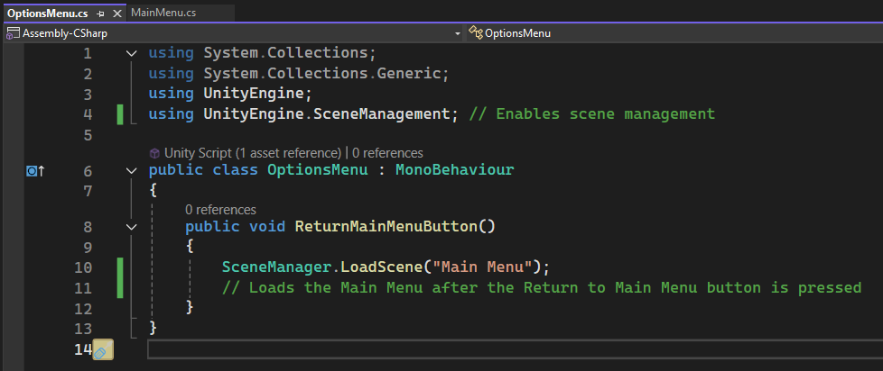

17. Add the Return button GameObject to its own “On Click ()” tab, and the OptionsMenu script as a component.

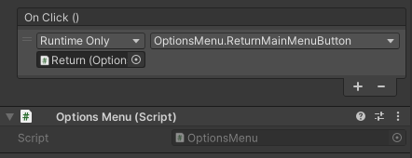

18. Add a heading to the scene with a text object, resize and reposition the button to your liking, edit its text and (optionally) add a custom source image. The Options Menu scene should now look something like this, and pressing the button should return you to the Main Menu.

